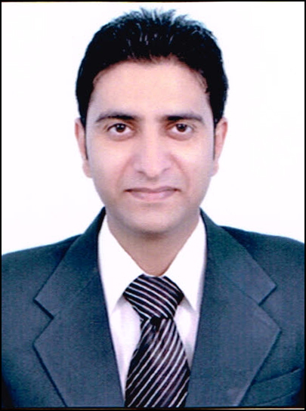
Priyank Karwal
H.No. 67, Khalwara Gate, Bedian Mohalla,
PHAGWARA. (Punjab)
MOBILE NO. : 98882-64678
E-mail: - priyank.karwal@yahoo.com

Career Objective:

Willing to serve an organization that would synergize my skills and experience with its objectives and provide me sufficient avenues for achieving personal & professional goals.

Academic Qualification:

MBA (Regular) 2009-2011
Aggregate 67%
Major : Finance
Minor : Marketing

B.Com (Regular) 2006-2009
Aggregate 55%
Under Guru Nanak Dev University, Amritsar.

+2 (Commerce) 2005-2006
Aggregate 60%
P.S.E.B.

Matric 2003-2004
Aggregate 70%
P.S.E.B.

Skills

- Positive attitude

- Honest

- Good communication and ability to convince people.
- Strong will-power and determination
- Team building and leadership qualities
- Problem Solving and Decision making ability

What can I contribute to your Organization

- Positive Attitude.
- Commitment towards work.
- Regularity and Punctuality
- Learning skills

Computer Literacy:

- Complete working Knowledge of MS-Word, MS-PowerPoint (MS office)

Achievements

- Got the trophy and Certificate Of Appreciation for best performance from vice-president in December 2013 -Kotak Life Insurance
- Got the Certificate Of Appreciation for Achieving of Zero Rework in PHF in 2013-14 in Kotak Life Insurance
- Got the Certificate Of Appreciation for Qualifying Renaissance 14 contest in from 25th August till 10th September 2014 in Kotak Life Insurance
- Got the certificate Excellence of work from the Zonal Manager in Birla Sun Life
- Got the trophy From the Regional Manager for the best work in SBI Life

Strengths

- Punctual, Hardworking, Confident
- I can perform well most of the all the task in respective condition.

Experience

- Birla Sun Life Insurance Company as an Agency Manager. (18/07/2011– 02/05/2012)

- SBI Life Insurance Company as a Unit Manager. (05/05/2012– 04/01/2013)

- Kotak Life Insurance as a Branch Operation Executive. (21/10/2013-30/09/2014)

Hobbies and Interests

- Reading, Listening Music, Playing Cricket

Personal Details:

Father’s Name: Sh. Sudarshan Karwal
Gender: Male
Date of Birth: 17 February 1987
Languages Known English, Hindi and Punjabi.
Ambition in life: To achieve excellence in my field of work.

Declaration:

I hereby declare that the above information is true, complete and correct to the best of my knowledge and belief. I hope that the proficient officer finds my background and strengths commensurate with the requirements of the company and the job.

(Priyank Karwal)

